# Media Analysis - ChatGPT AI grows more powerful as we become more predictable

## Short Summary

The article is about the rapid, widespread adoption and hype surrounding ChatGPT, an AI language model by OpenAI, which gained one million users within five days, signaling the start of the AI age. Despite its popularity, it's criticized for lacking human-like intelligence and ethical concerns arise regarding reinforcing ideologies.

## Summary

1. **Rapid Adoption**: The release of ChatGPT, an AI large language model owned by OpenAI, was met with unprecedented speed, attracting a million unique users within five days post-launch.  
   
2. **Emergence of AI in Developing Markets**: Companies and governments worldwide have rapidly adopted AI tools like ChatGPT due to the eagerness for an AI-powered future.  
3. **Predictability and AI Capabilities**: The technology, based on predictable human behavior analysis from large data sets, can generate content with educated guesses about trends in accessible data. However, it lacks the ability to reason like humans do.  
   
4. **Human-like Predictability vs Reasoning**: Despite our increasing online predictability due to algorithmic shaping of our behavior through internet usage, AI tools still struggle with human-like reasoning abilities.  
   
5. **Superficial Predictions by AI**: The predictions made by these AI models are based on probabilities that change over time and lack the ability to balance creativity with constraint, leading to either overgeneration of truths or undergeneration of decisions.  
6. **Ethical Concerns in Rapid AI Adoption**: Ethical issues arise from the potential for AI tools like ChatGPT to reinforce societal biases and worldviews, locking them in place without future contestation or improvement.  
   
7. **Beneficial Collaborative Use of AI**: Instead of replacing humans, AI should be utilized as a collaborative tool that enhances efficiency rather than completely taking over tasks, emphasizing the importance of incremental integration into human processes.

## Question 1:

How do the media in this article frame the public discussion about ChatGPT? Are there certain **metaphors** that keep cropping up?

The media in this article frames the public discussion about ChatGPT using metaphors that emphasize its rapid growth, potential impact, and limitations as a technology in its infancy. It portrays AI tools like ChatGPT as groundbreaking, quickly adopted, signaling the start of an 'AI age', still in their early stages despite rapid embrace, based on our predictable behavior, and positioned as foundationally limited compared to human cognitive abilities.

## Question 2:

Which role does or might the Arabic World play in the development of Artificial Intelligence? Answer with 'Not mentioned' if not applicable.

Not mentioned

## Question 3:

Which use cases of Artificial Intelligence are helpful for the Arabic world based on this article?

Enhanced communication e.g., language translation services , predictive behavior analysis for market or social media sectors, ethically mindful AI development

## Question 4:

What is the final message of the article that the author wants to convey? Keep your answer short and precise!

Caution in hasty adoption, emphasizing balanced use of AI tools for efficiency without replacing human creativity and decision-making.

## Sentiment

The sentiment is <2>

The sentiment in the article appears to be predominantly neutral to positive, with constructive criticism towards ChatGPT's limitations while highlighting its potential benefits. The author skillfully balances concerns about AI's predictability and reasoning capabilities with discussions on how these technologies can drive progress.

## Entities

Miss Vital Point Human Development Impact Society Ethical Issue, Joseph Dana Predictable Ai Tool Lack Fundamental Ability, White Paper Launch, Serendipitously Stumble Book Know, Microsoft, Joseph Dana, Https Microsoft Ethic Society Responsible Ai, Https Medium Arab News Country, New York Times, Openai Approach Chatgpt Notion Human Behavior Predictable Analyze Large Datum, Noam Chomsky

## Topic Clusters

### Cluster: ChatGPT and Arabic Language Integration

AI technology, Arabic language support, Chatbot development, Language translation capabilities

### Cluster: Societal Impact of AI in Education

AI-powered learning tools, Personalized education, Accessibility in education

### Cluster: AI Ethics and Responsibility

Accountability for AI decisions, Bias in AI algorithms, Privacy concerns

### Cluster: Arabic Media's Perspective on AI Advancements

Media coverage of AI developments, Cultural implications of AI, Public discourse

## Word Clouds

### Wordcloud of content

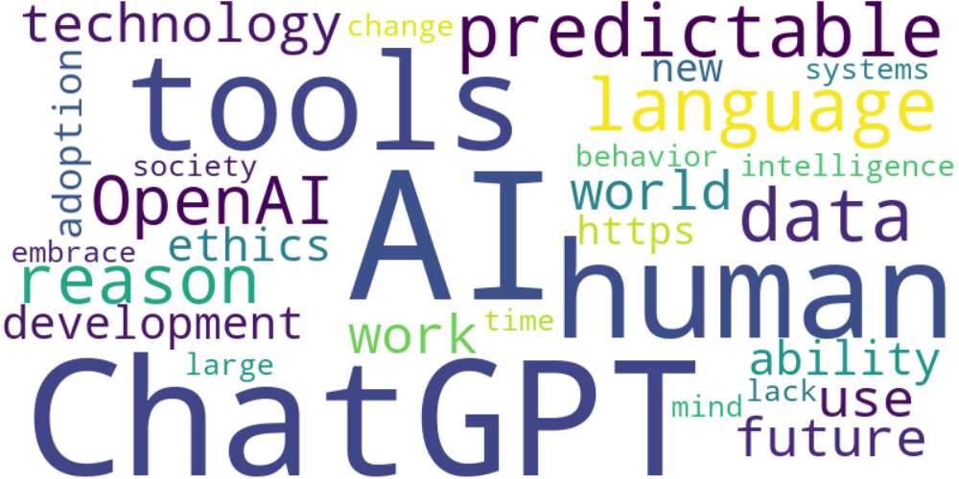

Top 10 words:

- AI: 15  
- ChatGPT: 12  
- tools: 8  
- human: 8  
- predictable: 6  
- language: 6  
- data: 6  
- OpenAI: 5  
- reason: 5  
- technology: 4

### Wordcloud of summary

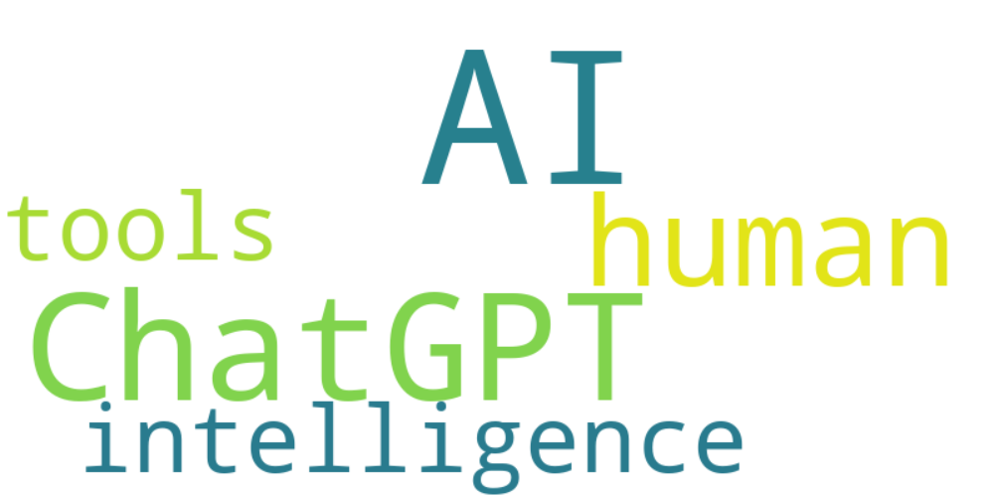

Top 10 words:

- AI: 12  
- like: 5  
- ChatGPT: 3  
- tools: 3  
- human: 3